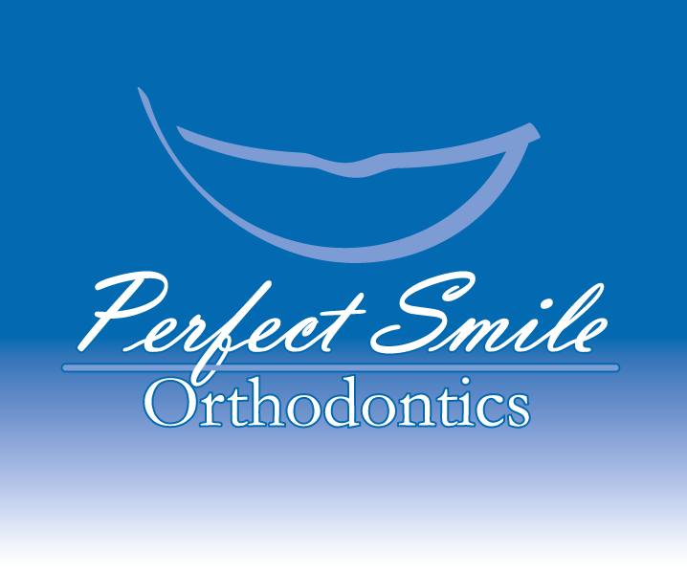

MEDICAL/DENTAL HISTORY

Patients Name_________________________________________________________________________
Physician_____________________________________________________ Date of last visit? ___________________
Address _______________________________________________________ Phone___________________________
Please circle yes or no (If Yes, please fill in details)
YES NO Are you taking any medication? _______________________________________________________
YES NO Are you allergic to any medication? ____________________________________________________
YES NO Do you have a history of a major illness? ________________________________________________
YES NO Are you currently under a physician’s care? ______________________________________________
Circle any of the medical conditions below that you have had or currently have.
Abnormal bleeding Diabetes Hepatitis/Liver problems Rheumatic Fever
Anemia Dizziness Herpes Tuberculosis
Arthritis Epilepsy High Blood Pressure
Asthma Heart Murmur HIV/AIDS
Congenital Heart Defect Heart Problems Kidney problems
Are there any medical conditions we have not discussed that you feel we should be aware of? ___________________ ______________________________________________________________________________________________

Dentist___________________________________________________________ Date of last cleaning ____________
What concerns you most about your teeth? ___________________________________________________________
Please circle yes or no
YES NO Have you ever seen an orthodontists? If yes, who and when?________________________________
YES NO Have your tonsils and adenoids been removed? __________________________________________
YES NO Are you allergic to latex? ____________________________________________________________
YES NO Are you allergic to nickel? ___________________________________________________________
YES NO Do you need antibiotics before seeing the dentist? ________________________________________
Please circle any of the dental conditions below that you have had or currently have.
Cold Sores Jaw/Facial Injuries Mouth Breathing Tension Headaches
Clenching/Grinding of teeth Jaw Clicking/Popping Ringing in the ears Thumb Sucking
Dental/Tooth Injuries Jaw Locking Smoke/Chew tobacco Tongue Thrust
Female Patients Only
Are you pregnant? _______________________________________________________________________________
Please circle Yes or No to the following question if you are under 14 years old:
YES NO Has menstruation started?
Are there any dental conditions we have not discussed that you feel we should be aware of? ____________________
______________________________________________________________________________________________
AFFIRMATION
I affirm that the information I have given is correct to the best of my knowledge. It will be held in the strictest confidence and it is my responsibility to inform this office immediately of any changes in medical status I hereby give Dr. Robinson and Team permission to confirm appointments using the phone number(s) or emails I have provided, to include leaving messages. In addition, I authorize Dr. Robinson to perform a complete orthodontic evaluation.

_____________________________________________________________________________________________________________
Patient/Parent/Guardian Signature Date

_____________________________________________________________________________________________________________
Doctor Signature Date

